**How to book** [**d.@rt**](mailto:d.@rt) **centre courses online**

Once you have done this once it all makes sense! If you need any support, please call us on 01489 779 471

1. Firstly, create your online account/ login at <https://wilderncommunity.legendonlineservices.co.uk/art_centre/account/login>

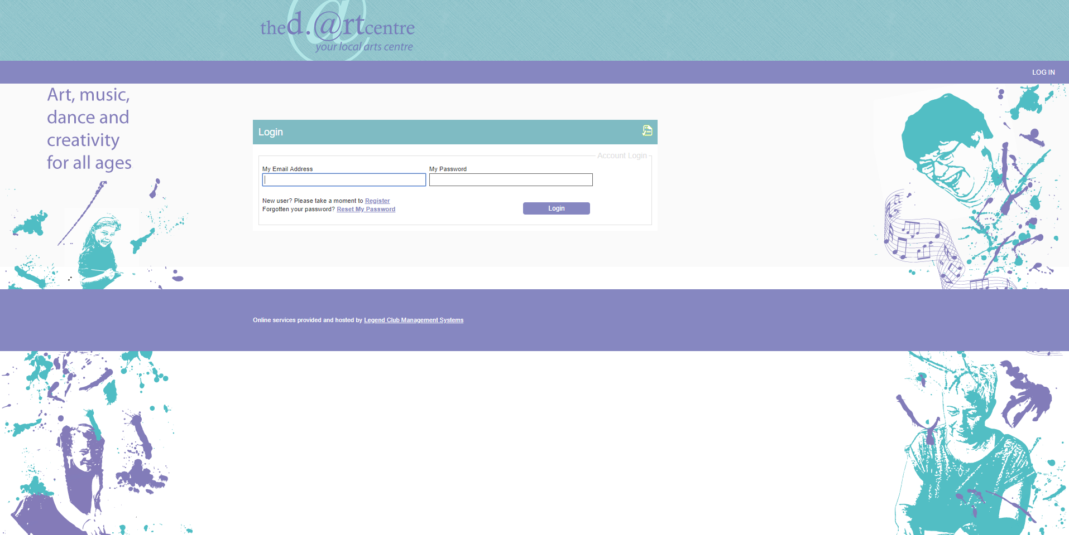

1. You will be taken to the dashboard where you should select ‘Search for Sports Courses’ on the left panel

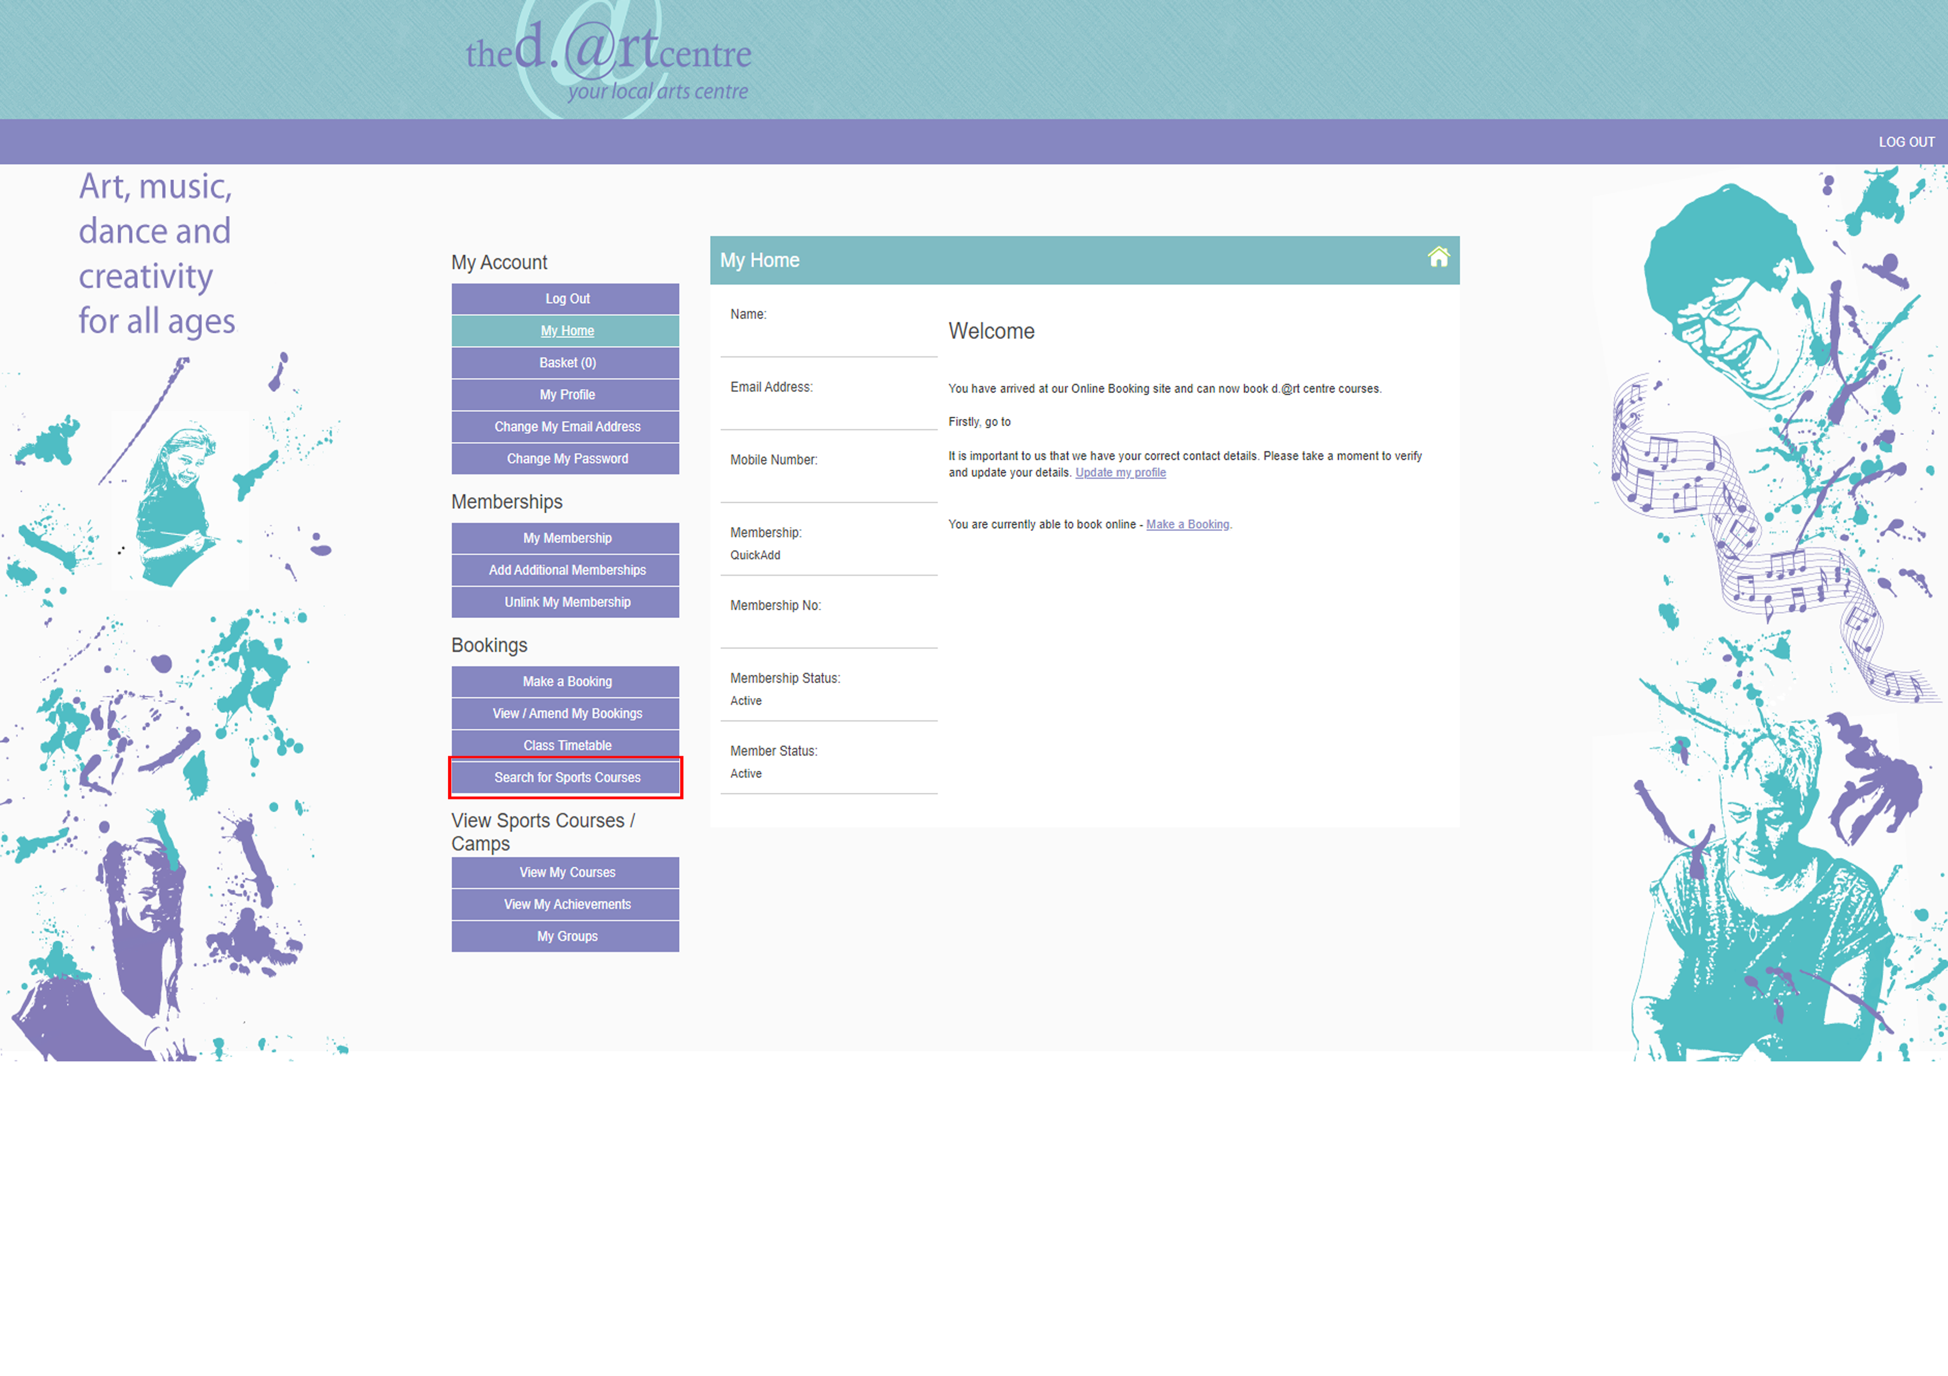

1. You now can now choose how you search for your [d.@rt](mailto:d.@rt) centre courses. You can search by date/ date range by selecting the green ‘filter’ button.

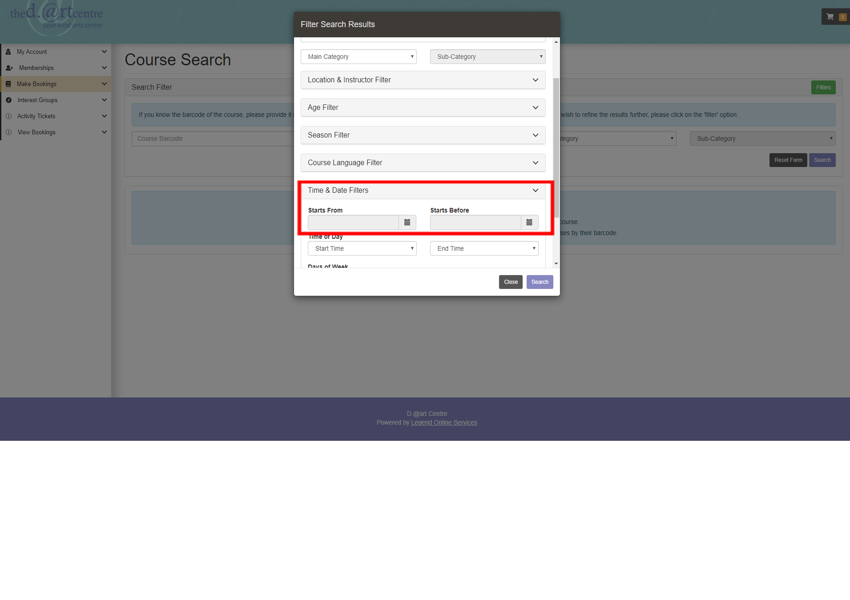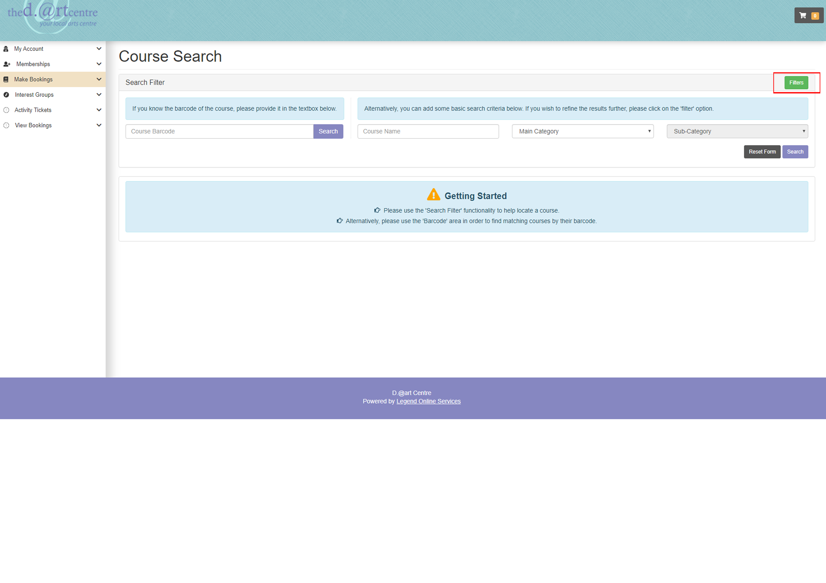

This is useful if you would like to know what is coming up on a certain Saturday as you can search for this date. Or if you would like to book any Children’s holiday activities you can input the date range and this will list all bookable courses.

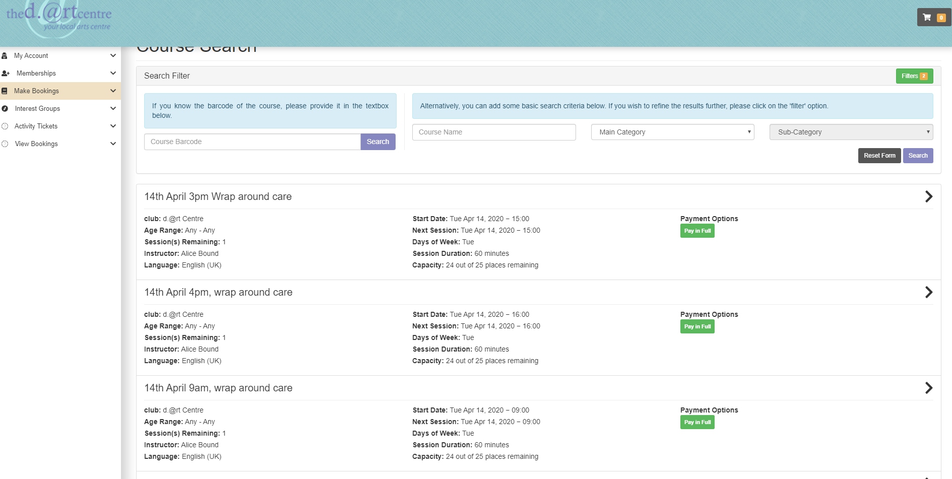

1. Select the course that you wish to book. Ensure you have selected the correct date and click register in the bottom right corner.

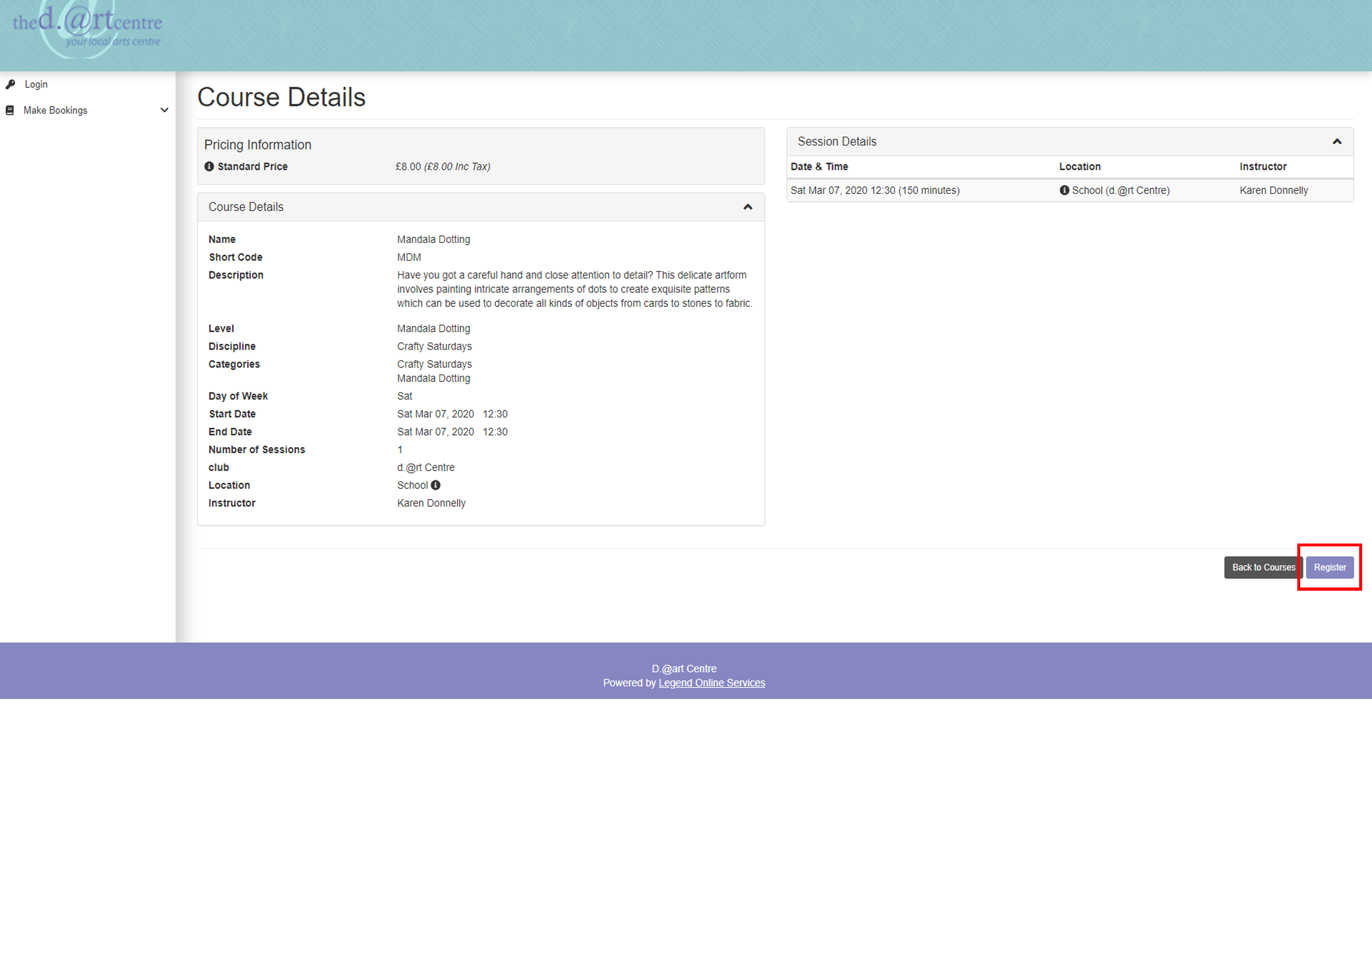

1. Here you need to select the participant using the drop down selection. If you are booking a course for yourself, simply chose your name. If you are booking on behalf of your child or a friend you will need to choose their name.

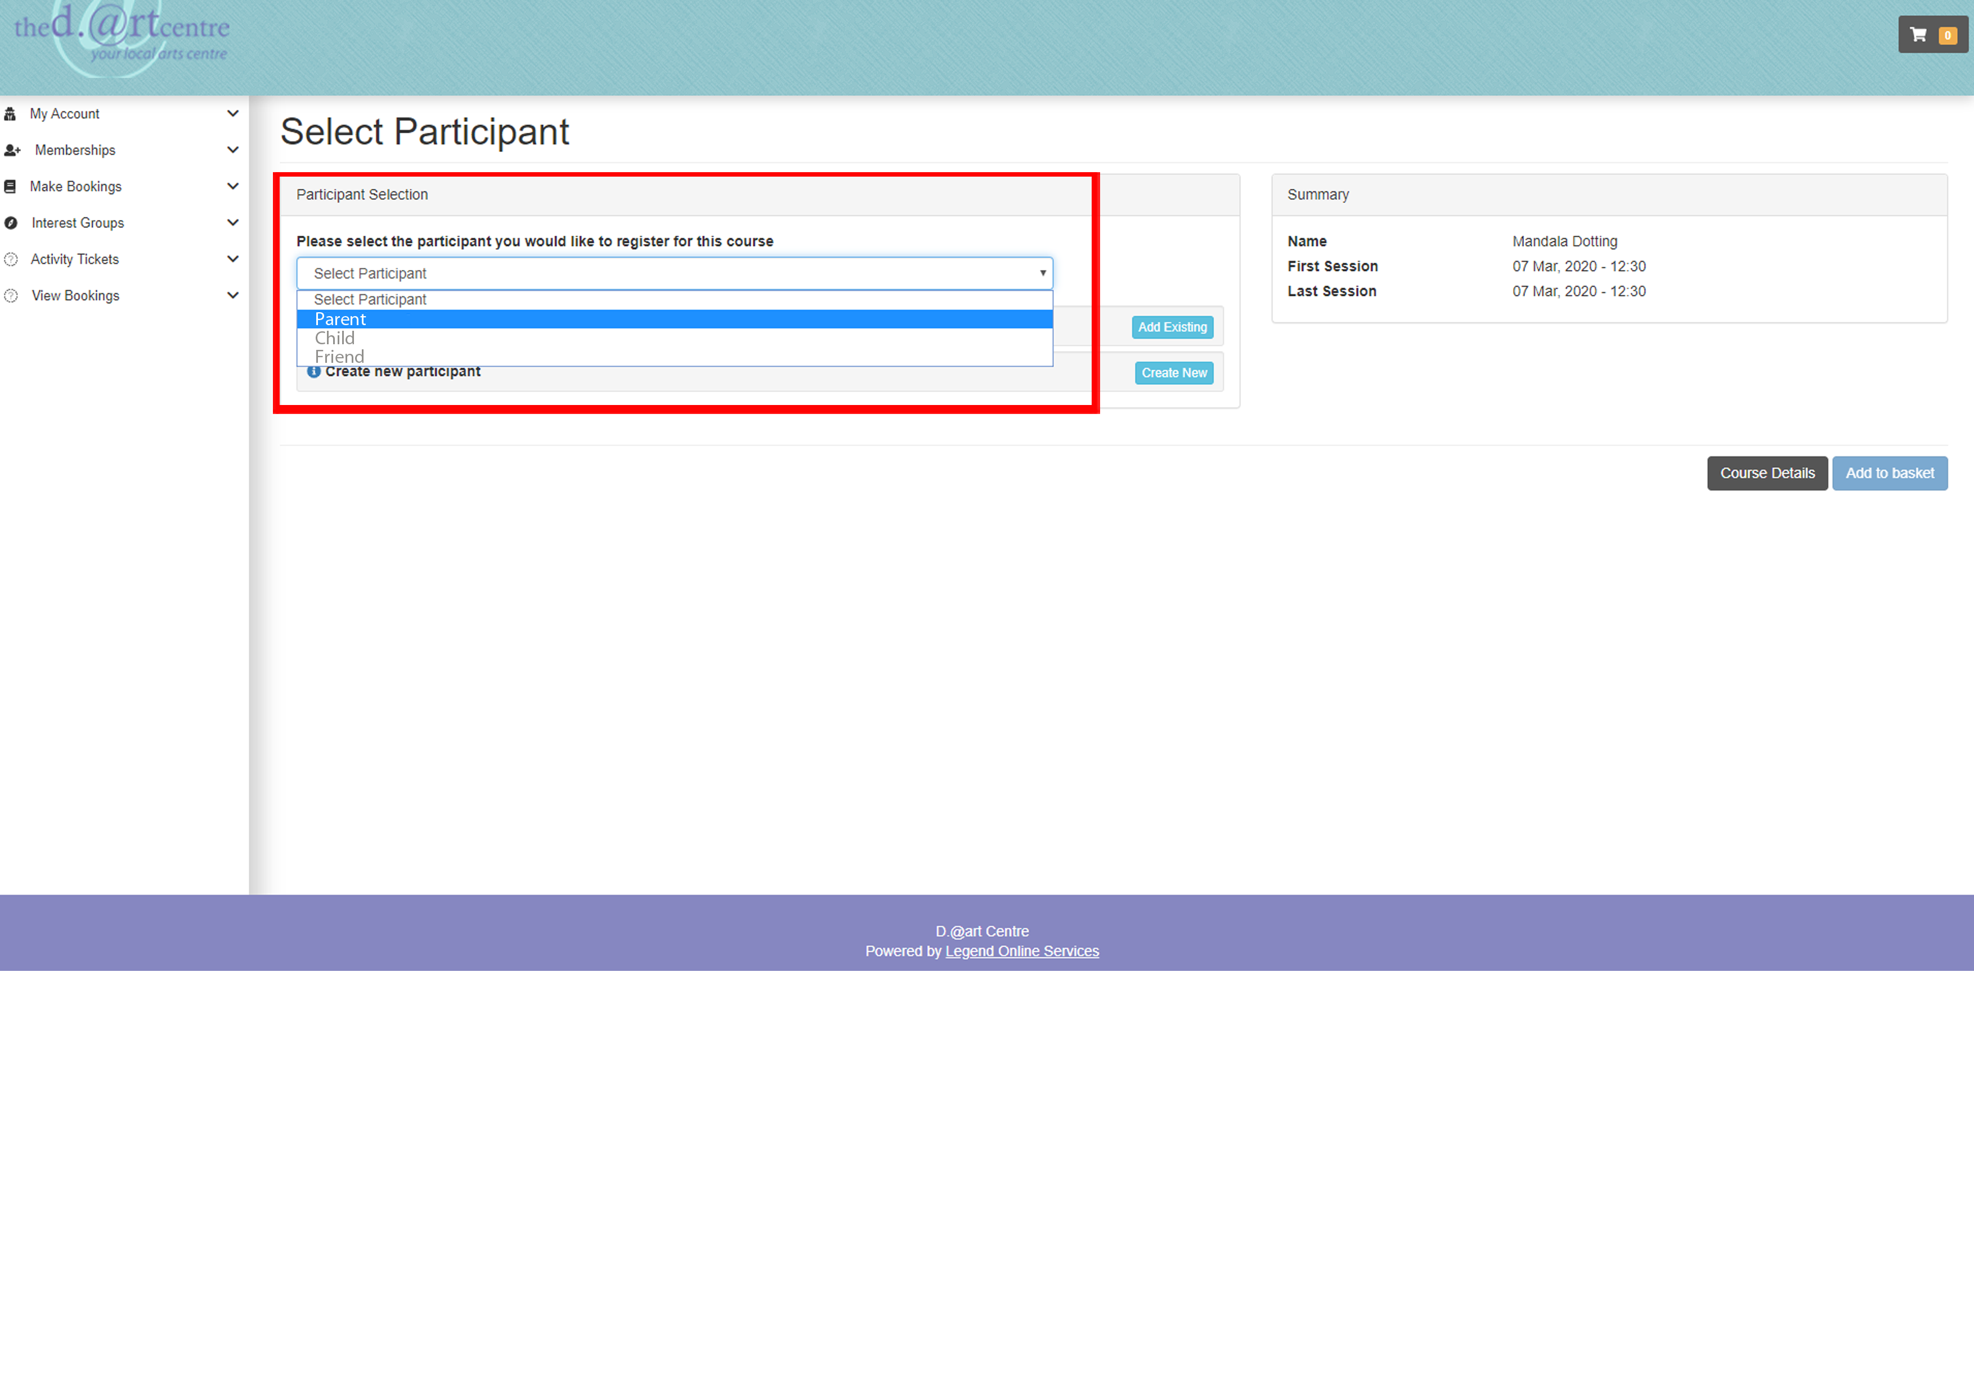

If you do not have your child/friend registered on your account, you need to select Add existing participant (if you know they have booked with the [d.@rt](mailto:d.@rt) centre before, they already have a membership number, please enter their membership number here), they will now be listed on the ‘Select Participant’ drop down.

If they have not booked with the d.@rt centre before, please select create new participant and follow the instructions by entering the details of the new member. They will then be listed on the ‘Select Participant’ drop down.

1. Select your participant and add to basket.

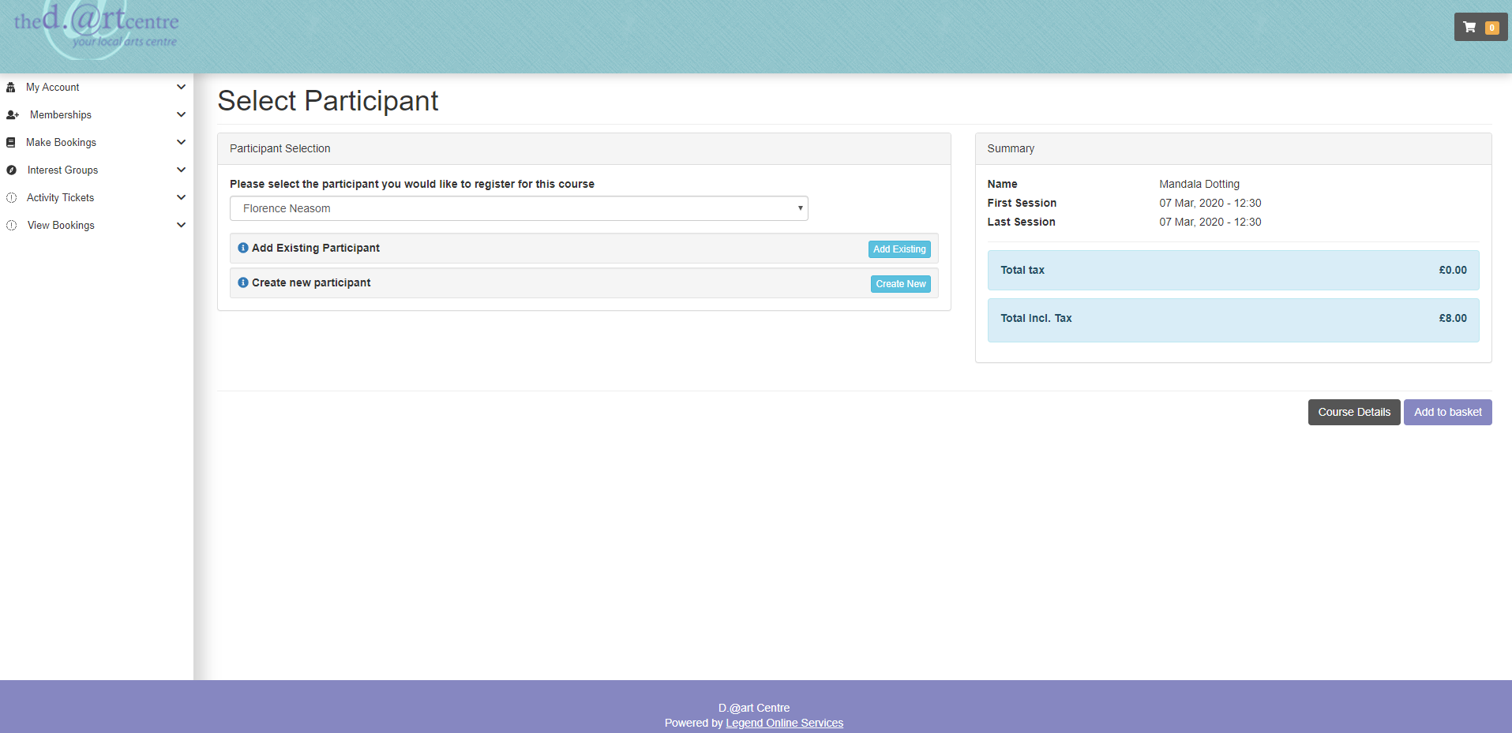

1. Check your basket and ‘proceed to payment’. Or make another booking using the ‘Book another’ dropdown and selecting ‘Search for Sports Courses’ where you will be taken back to the course search page.

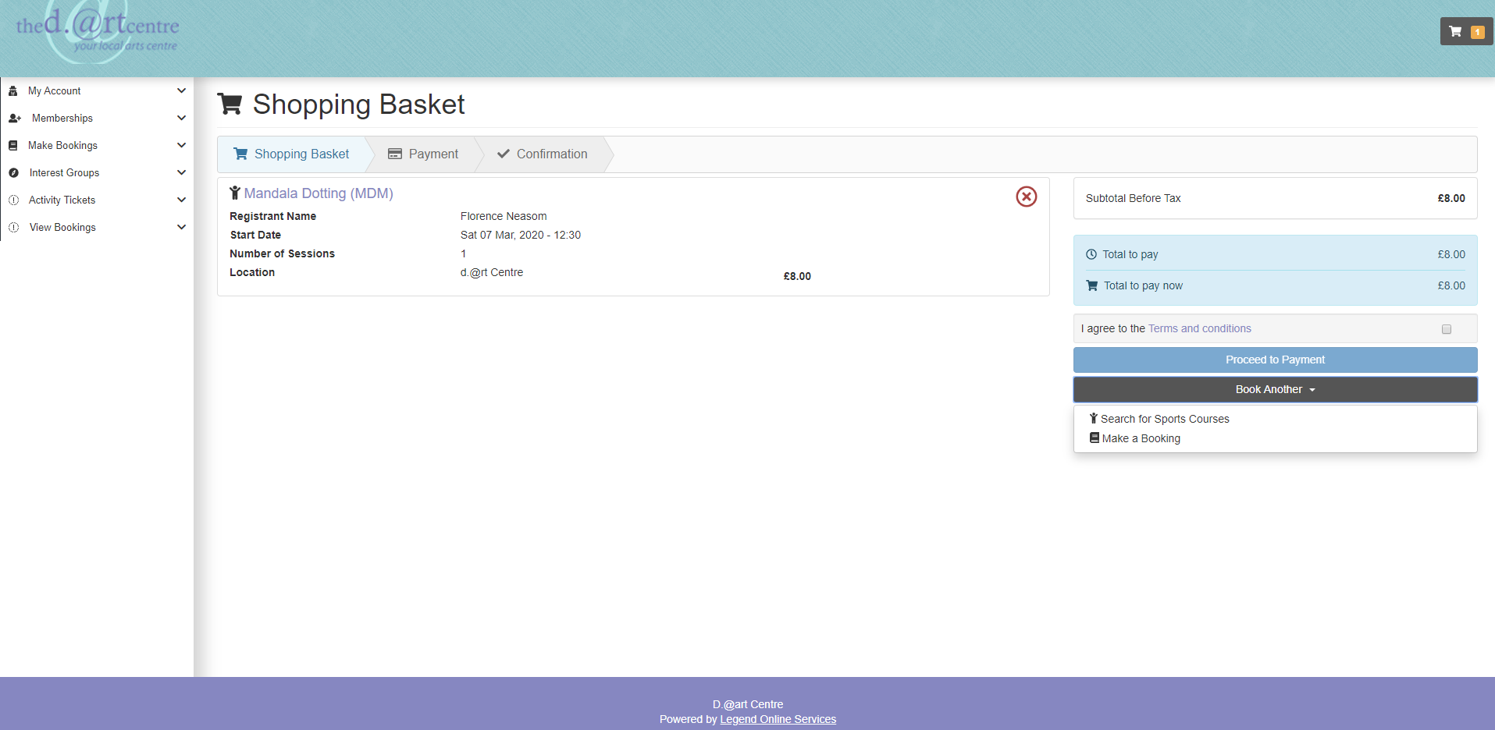

1. You will receive a confirmation email to the email address you are registered with. If you do not receive an email receipt/confirmation, please contact community@wildern.org